**Part 1 Ethernet frame analyzing**

1. What is the 48-bit Ethernet address of your computer?

The 48-bit ethernet address of my computer is

Intel_72:be:60 (10:a5:1d:72:be:60)

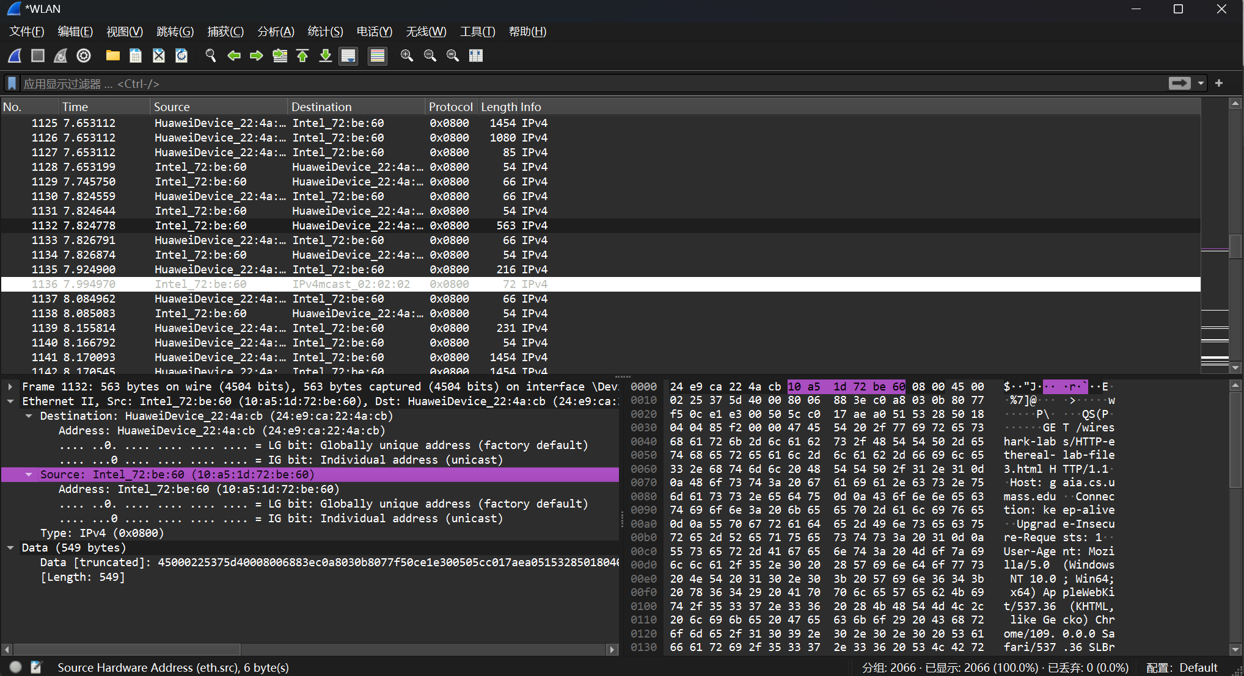

My frame

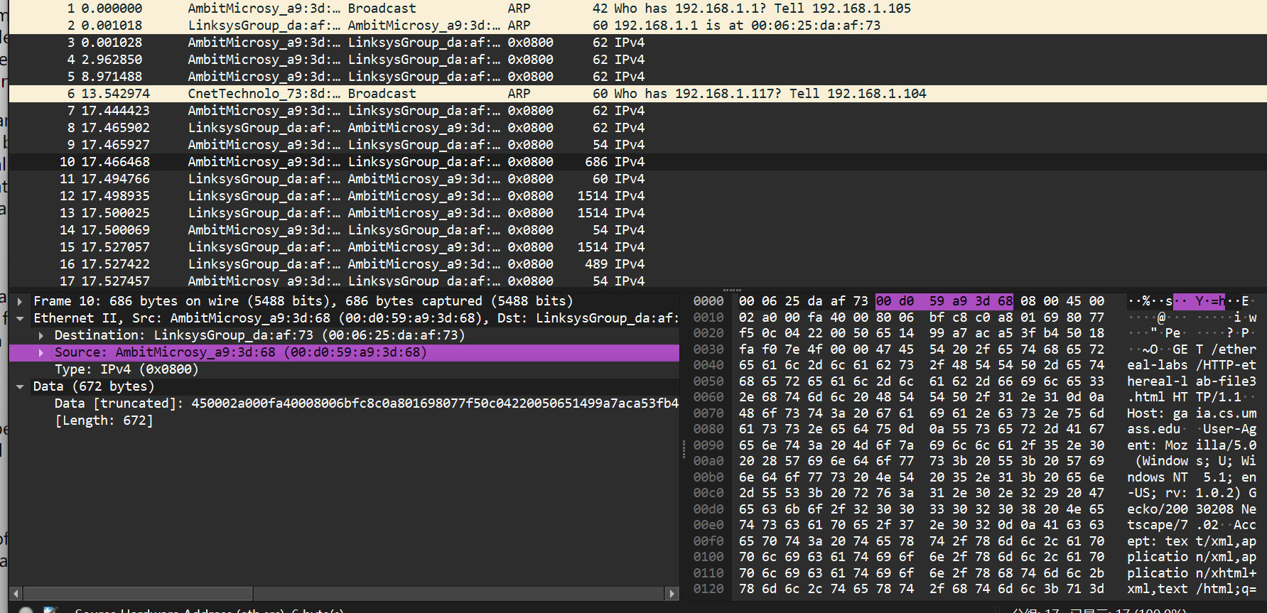

Provided frame

Each computer has a mac different address

1. What is the 48-bit destination address in the Ethernet frame? Is this the Ethernet address of gaia.cs.umass.edu? (Hint: the answer is *no*). What device has this as its Ethernet address?

The 48-bit destination address in the Ethernet frame is

HuaweiDevice_22:4a:cb (24:e9:ca:22:4a:cb)

This is not the Ethernet address of gaia.cs.umass.edu

The device is the route which my computer is connected, this should be the address of the outgoing subnet.

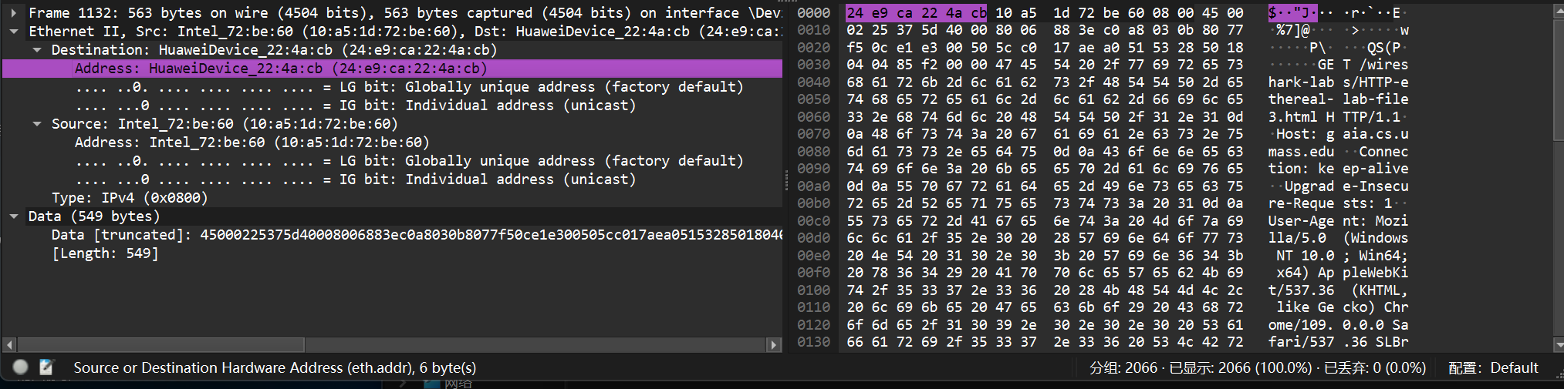

My frame

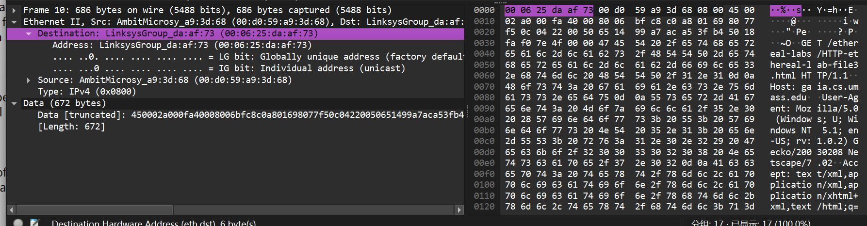

Provided frame

If the virtual route is different, the address obtained is different

1. Give the hexadecimal value for the two-byte Frame type field. What upper layer protocol does this correspond to?

The hexadecimal value for the two-type Frame type field is 0x0800.

This corresponds to the IPv4 protocol at the network layer

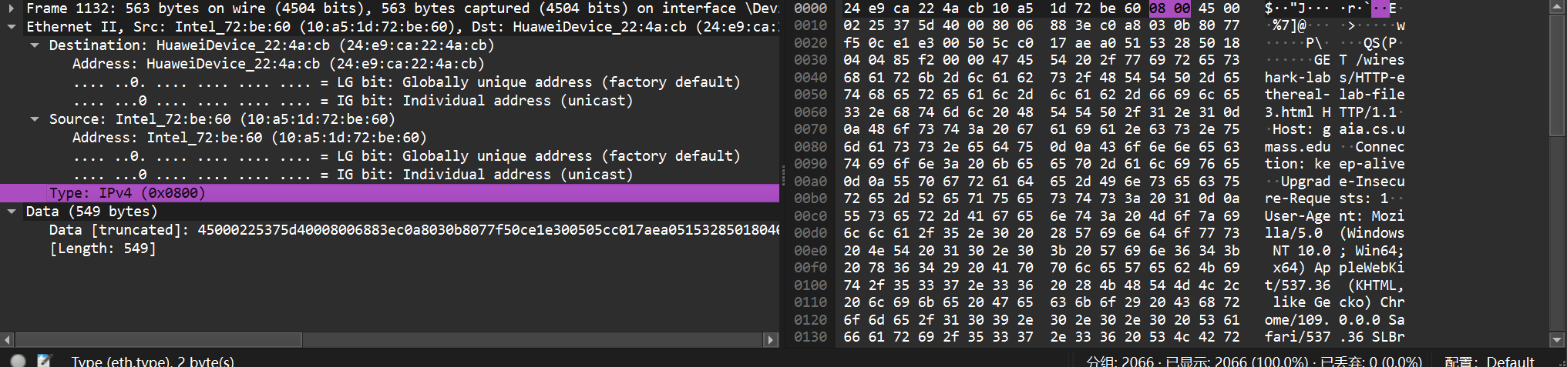

My frame

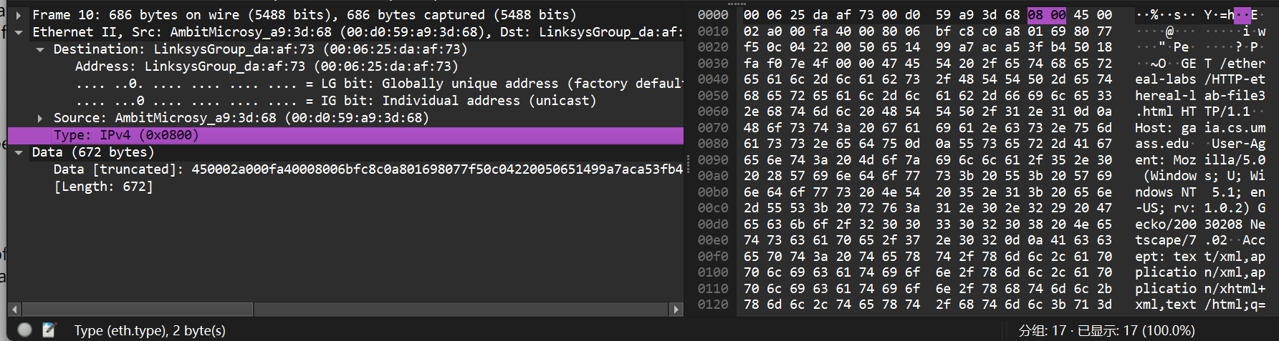

Provided frame

The upper-layer protocols of Ethernet frames are consistent

1. How many bytes from the very start of the Ethernet frame does the ASCII “G” in “GET” appear in the Ethernet frame?

The first, second, and third rows are all 16 bytes, for a total of 48 bytes, and the fourth row to G has a total of 7 bytes, so a total of 55 bytes

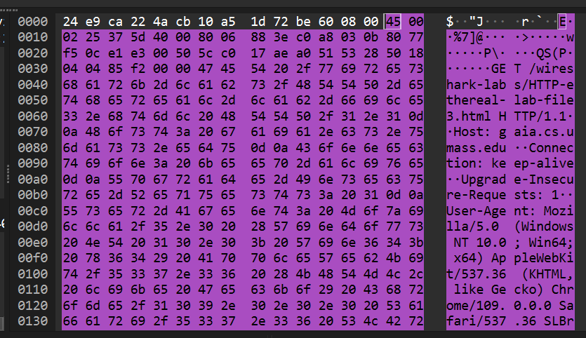

My frame

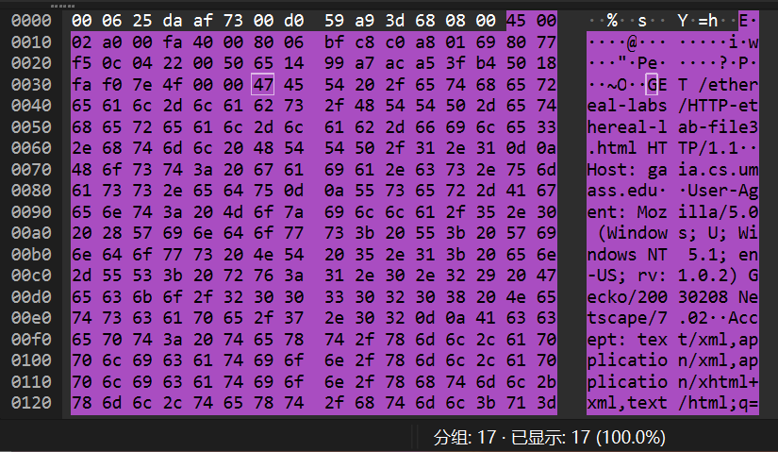

Provided frame

The same.

1. What is the value of the Ethernet source address? Is this the address of your computer, or of gaia.cs.umass.edu (Hint: the answer is *no*). What device has this as its Ethernet address?

The Ethernet source address is 10:a5:1d:72:be:60

The device with this Ethernet address is the router on the outgoing subnet.

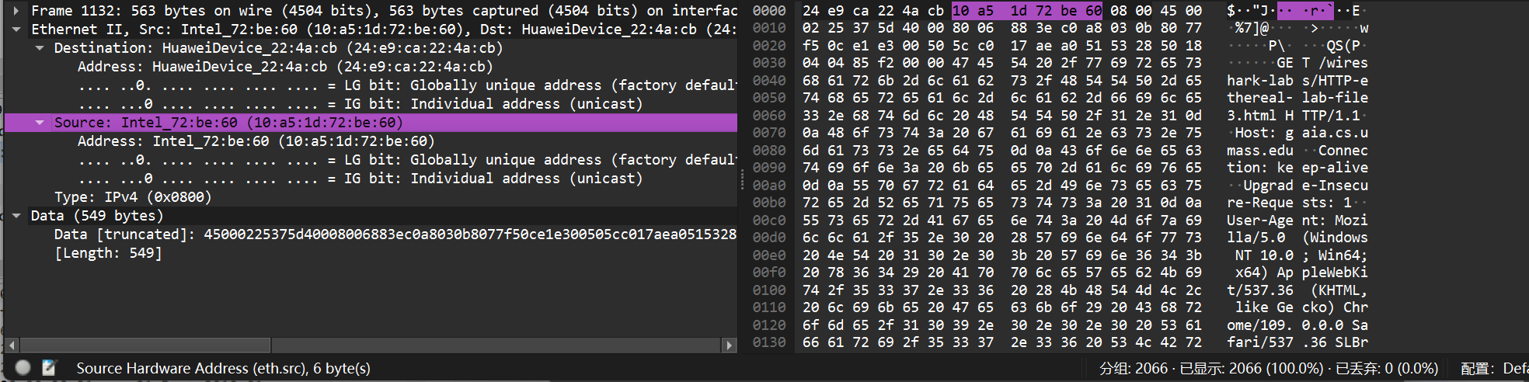

My frame

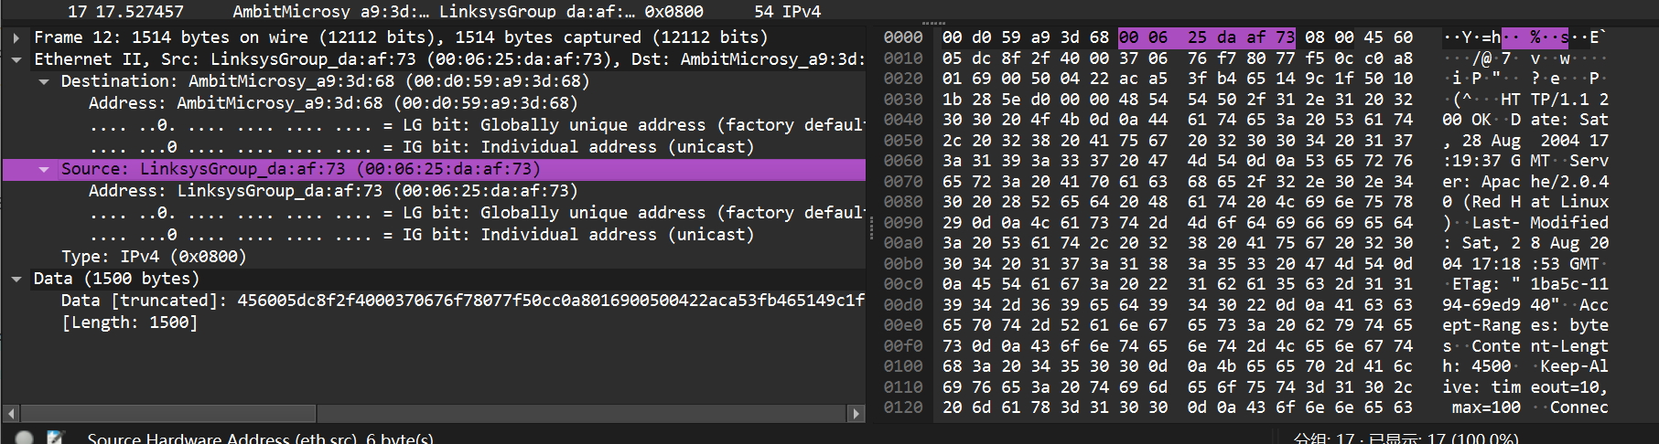

Provided frame

His virtual routing address

1. What is the destination address in the Ethernet frame? Is this the Ethernet address of your computer?

Destination :24:e9:ca:22:4a:cb

This is the Ethernet address of my computer.

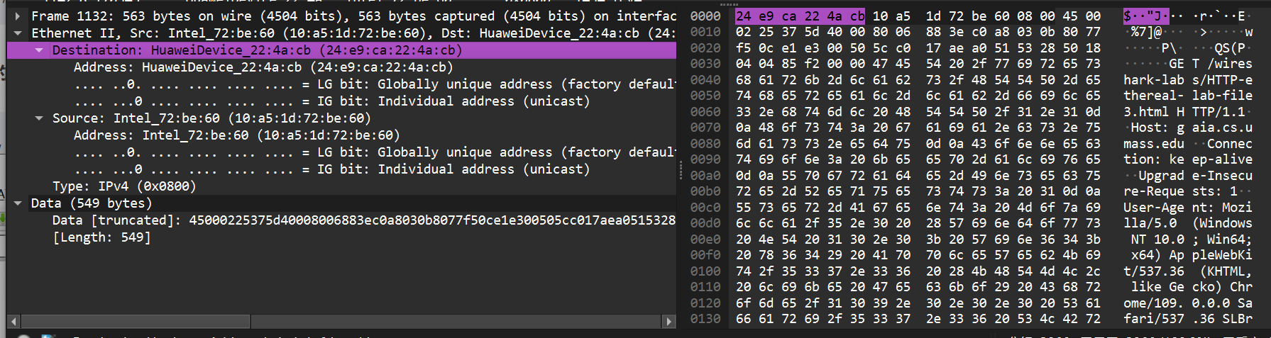

My frame

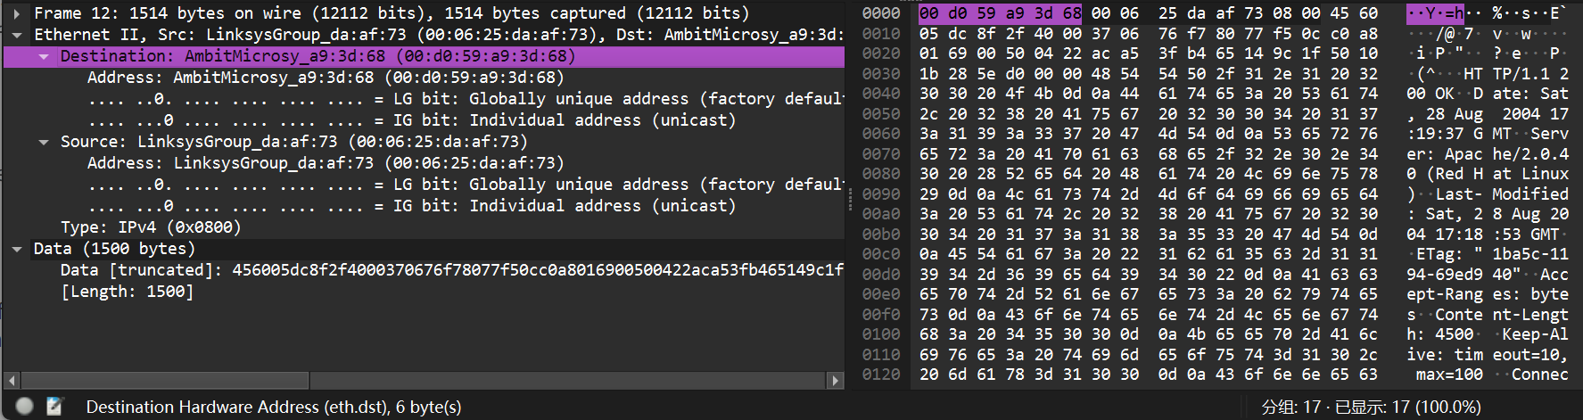

Provided frame

The Ethernet address of his computer

1. Give the hexadecimal value for the two-byte Frame type field. What upper layer protocol does this correspond to?

0X0800

This corresponds to IPv4 protocol at the network layer

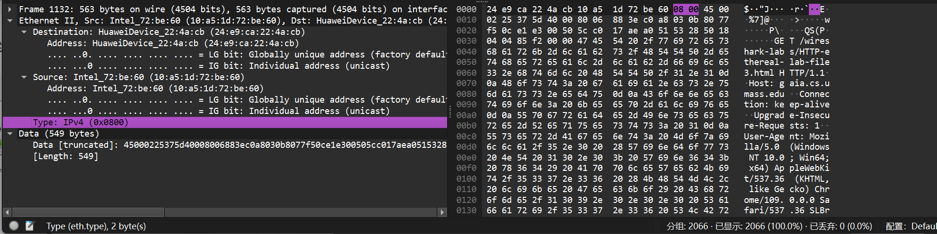

My frame

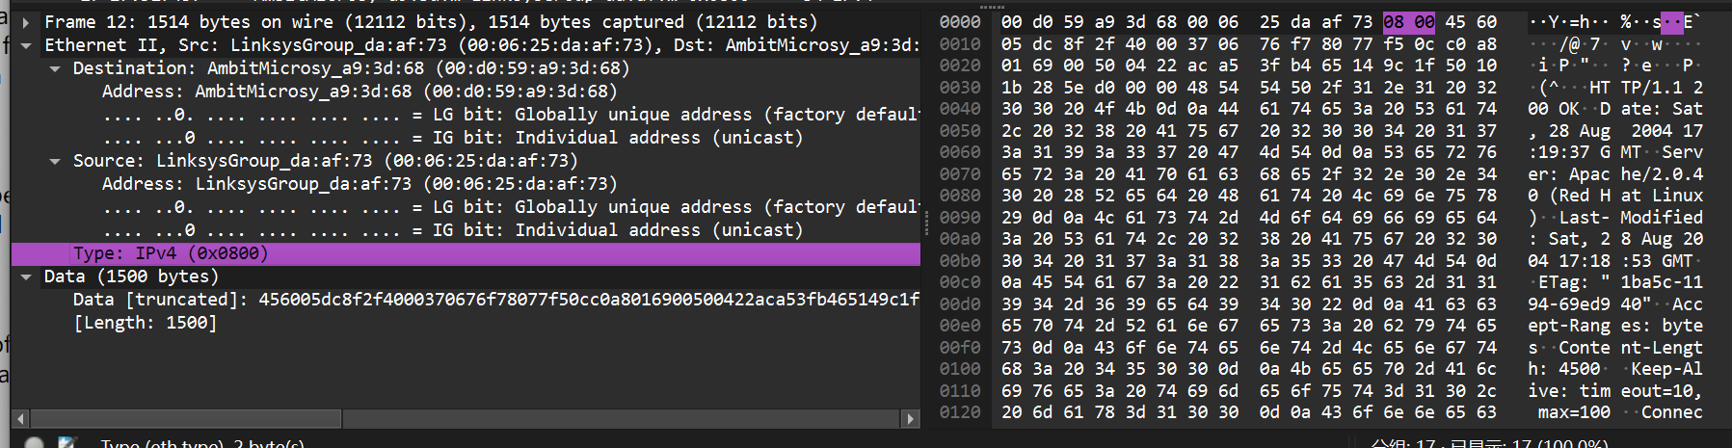

Provided frame

The same.

1. How many bytes from the very start of the Ethernet frame does the ASCII “O” in “OK” (i.e., the HTTP response code) appear in the Ethernet frame?

16 x 4 + 4 = 68 Byte

68 bytes from the very start of the Ethernet frame until the ASCII “O” in OK appear.

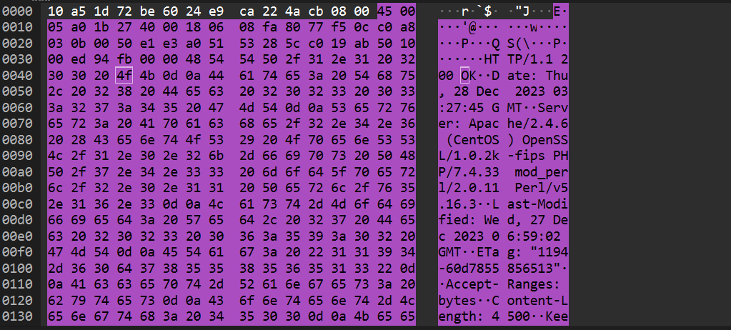

My frame

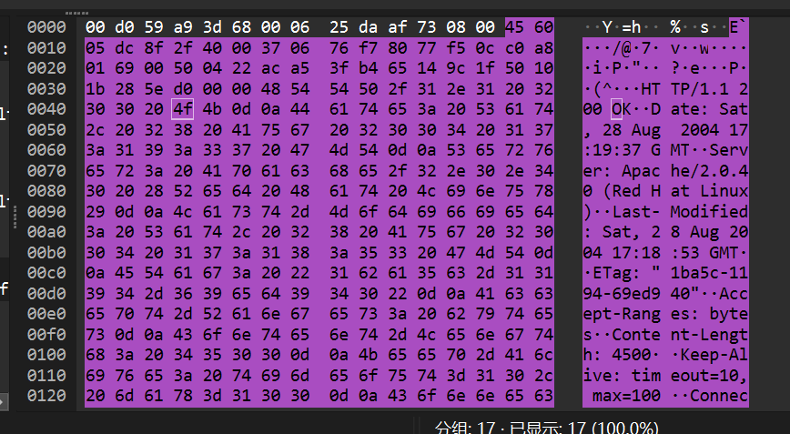

Provided frame

The same.

**Part 2 Address Resolution Protocol**

**Note: Due to I have no wireless router, so I can’t show the message**

1. What are the hexadecimal values for the source and destination addresses in the Ethernet frame containing the ARP request message?

Destination addresses: Broadcast(ff:ff:ff:ff:ff:ff)

Source addresses: AmbitMicrosy_a9:3d:68 (00:d0:59:a9:3d:68)

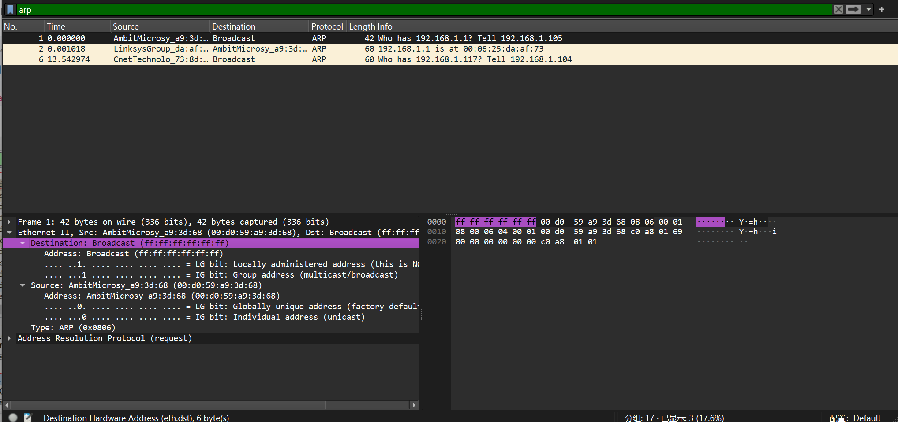

1. Give the hexadecimal value for the two-byte Ethernet Frame type field. What upper layer protocol does this correspond to?

0x0806. This corresponds to the ARP.

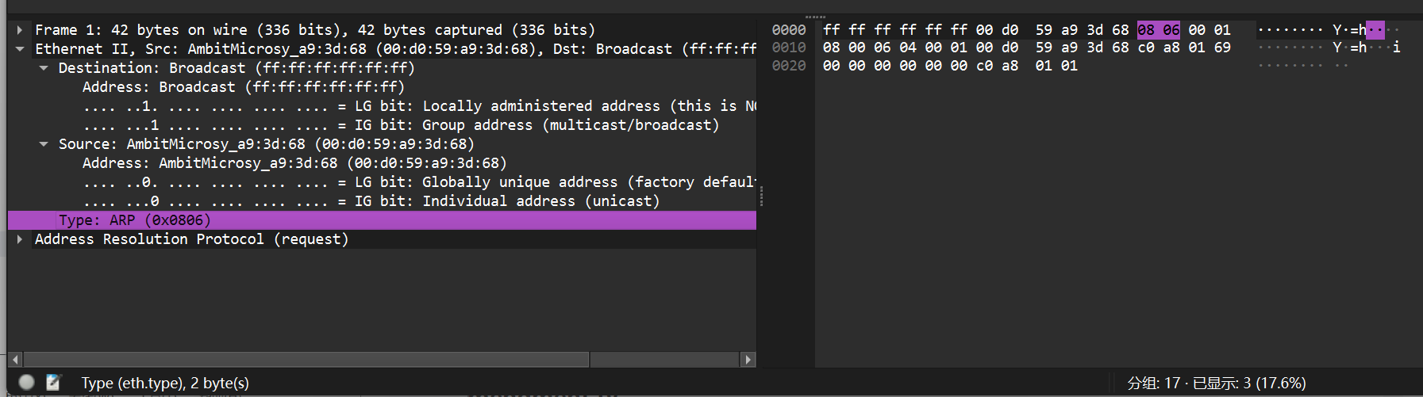

13. Now find the ARP reply that was sent in response to the ARP request.

a) How many bytes from the very beginning of the Ethernet frame does the

ARP opcode field begin?

16 + 5 = 21

21 bytes from the very beginning of the Ethernet frame to the ARP opcode field

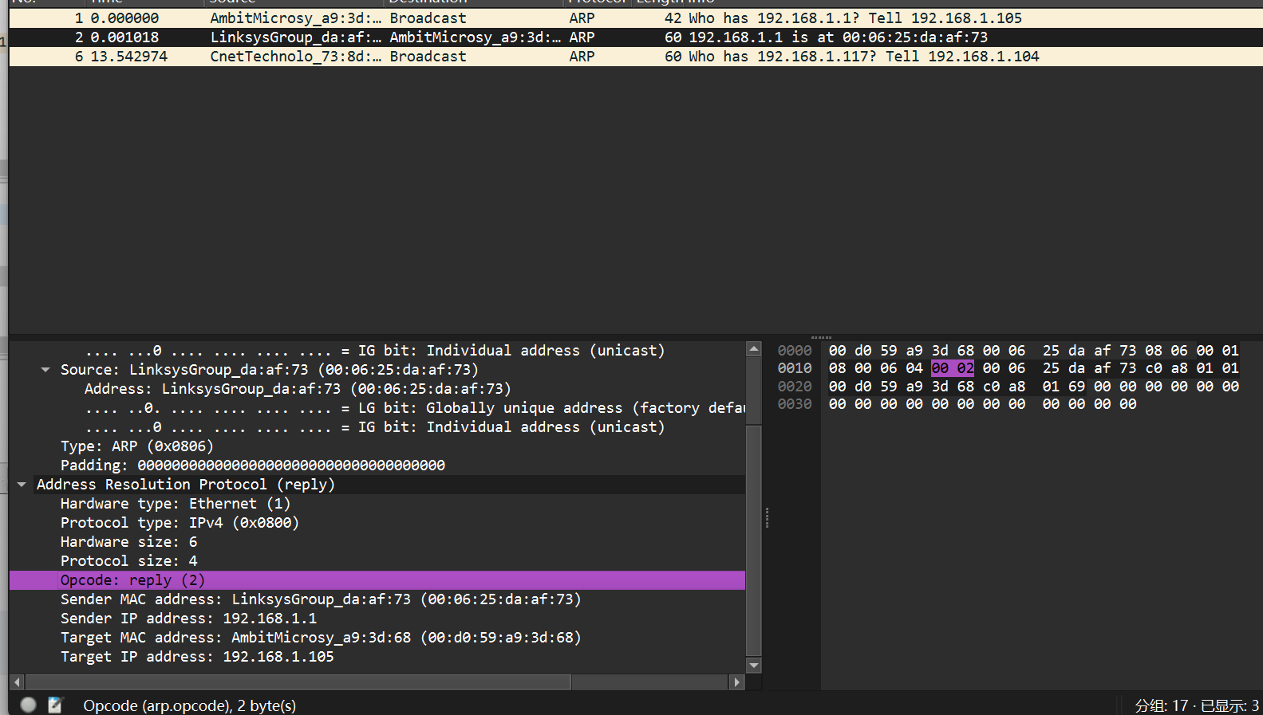

b) What is the value of the opcode field within the ARP-payload part of the

Ethernet frame in which an ARP response is made?

The value of the opcode field within the ARP-payload part of the Ethernet frame is 2



c) Where in the ARP message does the "answer" to the earlier ARP request

appear - the IP address of the machine having the Ethernet address whose

corresponding IP address is being queried?

The "answer" to the previous ARP request is shown in the following figure

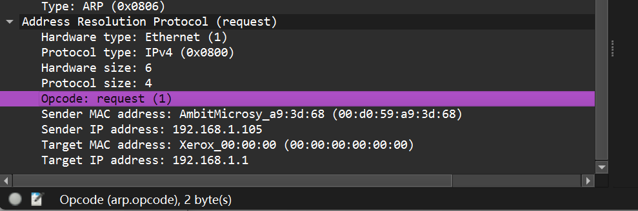

14. What are the hexadecimal values for the source and destination addresses. in the Ethernet frame containing the ARP reply message?

Source : 00:06:25:da:af:73

Destination: 00:d0:59:a9:3d:68

